INSTRUCTIONS FOR CREATING AND FILLING OUT THE EXHIBITOR'S PERSONAL ACCOUNT

2020

Registration of users

Before entering information about the Exhibitor's company, you must register on the website. Video instructions on how to register can be viewed on the official Expodat’s channel on YouTube or by following the link:
https://www.youtube.com/watch?v=i2TisvmJiZg
Below is a step-by-step instruction on how to register a user on the site:
- Enter the site name in the browser's address bar «expodat.com»
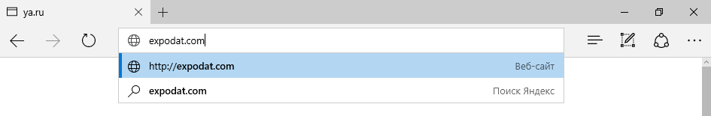
- The "Sign up" button is located on the main page of the site. Press it.
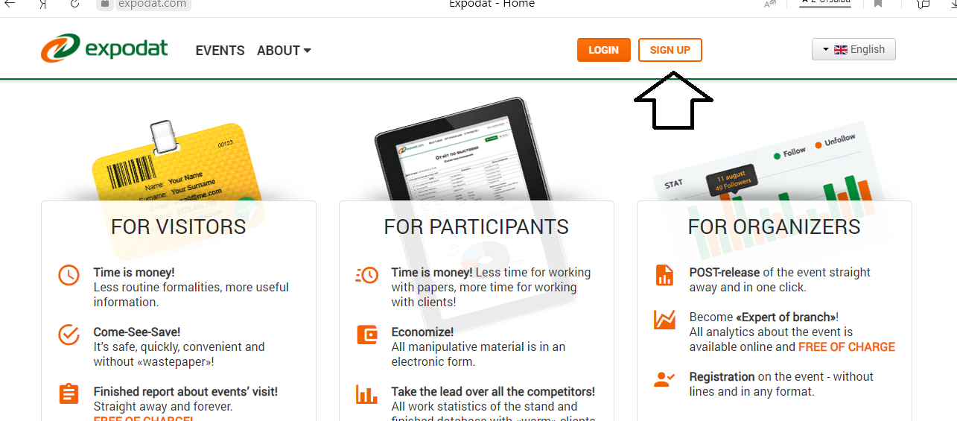
- In the registration window that opens, enter your information. Required fields "Last Name", "First Name" and " E-mail»:
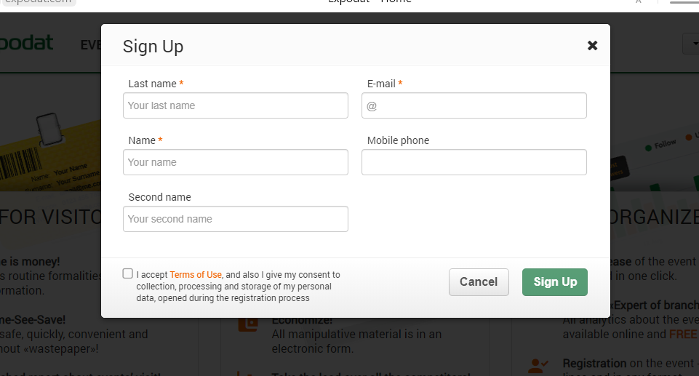
- Confirm your agreement with the " Term of Use "and click "Sign Up". As a result, a Personal account will be created for You, and an email with a temporary password will be sent to the E-mail specified during registration.

- Go to your mailbox and open an email with the subject "Expodat Service – user registration". The email contains a temporary "Password" from Your personal account:
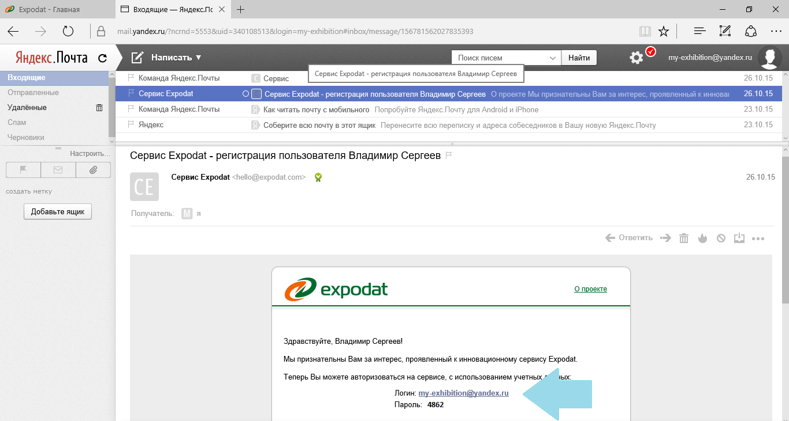
- Go back to the site page expodat.com and click the "Login" button. In the authorization window, enter the e-mail specified during registration in the "Login" field, and the "Password" field, the password which you received in the email:
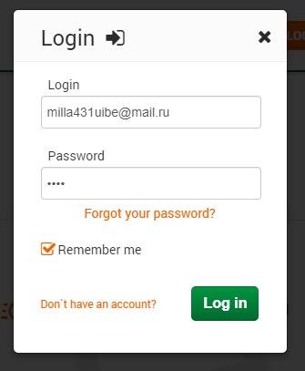
- After clicking the "Log In" button, you will be taken to the Personal account created for You. The user menu with control commands is located on the left border of the screen:
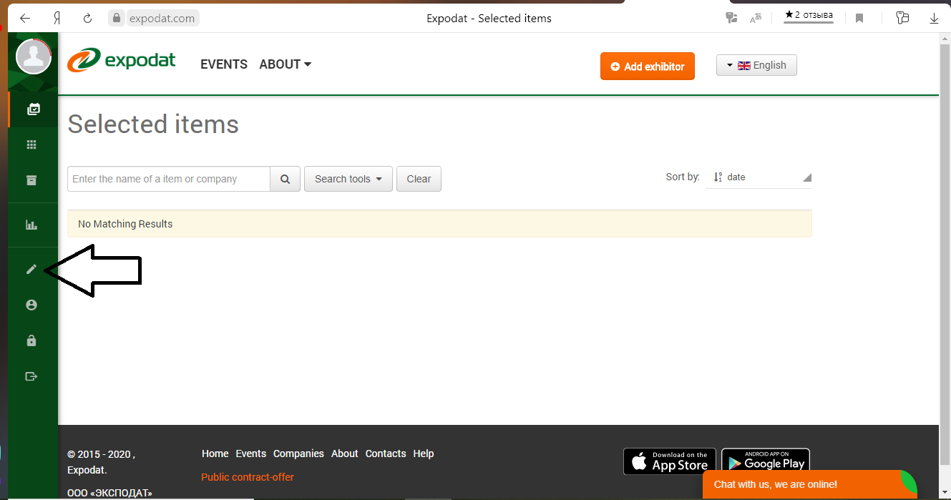
- Use the "Edit profile", "Change avatar", and "Change password" commands to add or change your personal account settings.

Creating a company page

After you have created your Personal account, you can start creating your organization's page. To do this, follow these steps:

- The "Add Exhibitor" button is located in the upper-right corner of the personal account page. Press it.
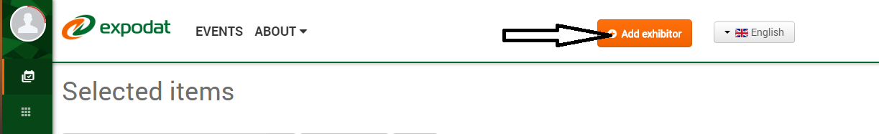
- In the "Add company" window, fill in the required fields:
  - "Short name" - it is displayed in the site lists. It is recommended to specify it as it will be specified in the event catalog. It will be used by site users to search for your company's page on the site.
  - "Name" - the full name of the legal entity (or individual entrepreneur) that entered into an agreement with the event organizer.
- In the same window, use the "Upload" buttons to add images:
  - "Organization logo" - your company's corporate logo, which will be placed on the organization's page and Expodat terminal;
  - "Cover" - an additional graphic banner that will be located in the header of the organization's page. The optimal cover size is 770*257 pixels. If the cover you uploaded doesn't match the recommended size, it will be scaled to the larger edge and cropped to the smaller one.
- Click the "Save" button to record the information. As a result, Your organization's page will be created.
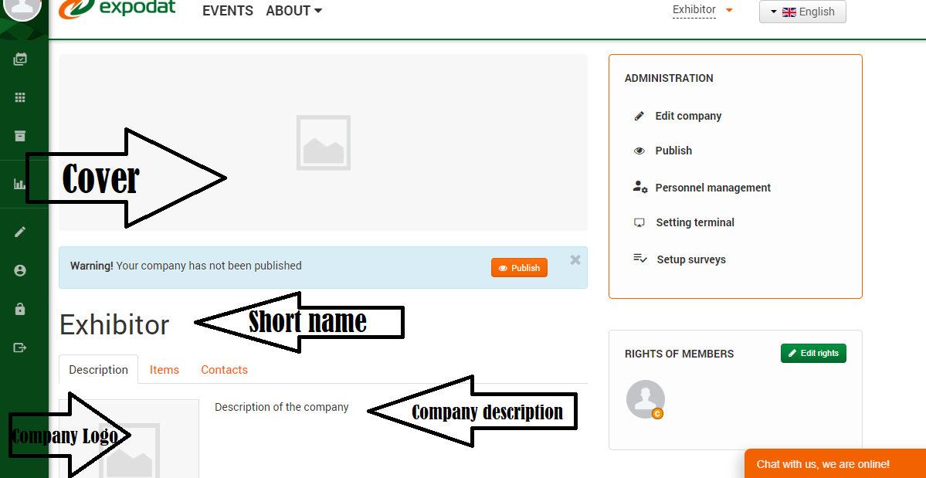
- If you need to change the company information you entered, use the "Edit company" command in the "Administration" panel located in the upper-right corner of the page.
- By default, the organization page that is being created is not visible to site users. When you have completed its design, click the "Publish" button (located in the "Administration" panel).

Video instructions on how to register a company can be viewed on the official Expodat channel on YouTube or by following the link: https://www.youtube.com/watch?v=nUC3Fc8WBag
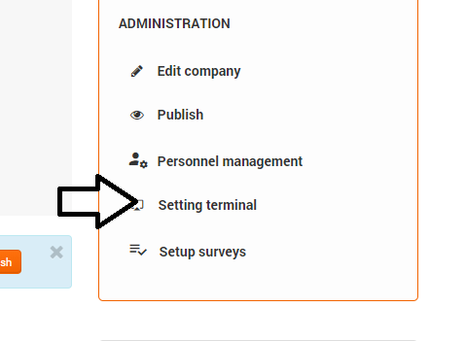

Placement of information materials

"Items" is an information entity that is used to form a package of electronic materials that the Exhibitor wants to convey to Visitors. The item has a Name, Image (graphic image), and Description.
In order to unify and meet the ergonomic requirements for the information presented, the terminal screen is divided into 6 positions, each of which is intended for displaying one item.

Video instructions on how to Add information items can be viewed on the official Expodat channel on YouTube or at the link: https://www.youtube.com/watch?v=X6mMBEfTslQ

Below is a step-by-step guide for adding an item.

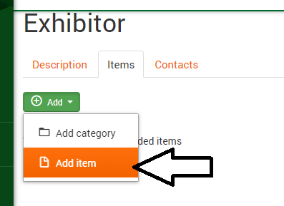
Adding an item
To add a new item to the organization's directory, run the following sequence of actions:
- Log in to the site and go to your organization's page.

- Open the “Items” tab..

- Click the "Add" button and select "Add Item":

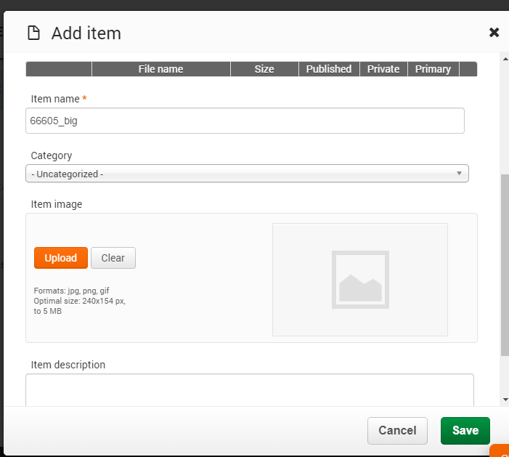
- In the "Add object" window, fill in the "Item Name" and "Item Description" fields. Use the "Browse" button to add an image of the object, which will be displayed on the terminal screen along with the name:

- To save information to the database, click " Save".

You can see how the created object will be displayed on the terminal by switching to the "Description" tab. In the example above, it will look like this:
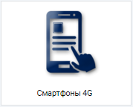
After switching to the "Description" tab for some browsers, you need to refresh the page (this can be done by pressing the "F5" keyboard button).

Additional features for managing objects
If you need to make a change to the item description or change the image, use the "Edit" command in the toolbar:
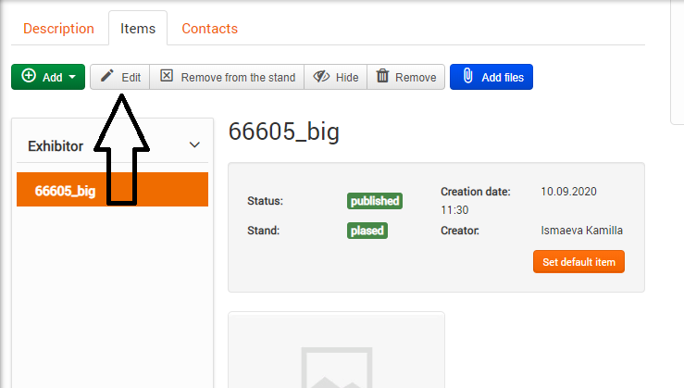
For each created item, you can attach one or more files. To do this, use the "Add files"button.

Maximum file size: 250 MB. Acceptable file formats: png, jpg, jpeg, gif, zip, rar, doc, docx, xls, xlsx, pdf, ppt, pptx, txt, 7z, gz, wav, mp3, avi, mpeg, mpg, mp4.

The "Hide" command allows you to change the state of the item – it becomes invisible to all site visitors except You (and your colleagues who have access to the company's content management). For the Reverse operation, use the "Publish" button that appears in the same place on the toolbar for unpublished objects.

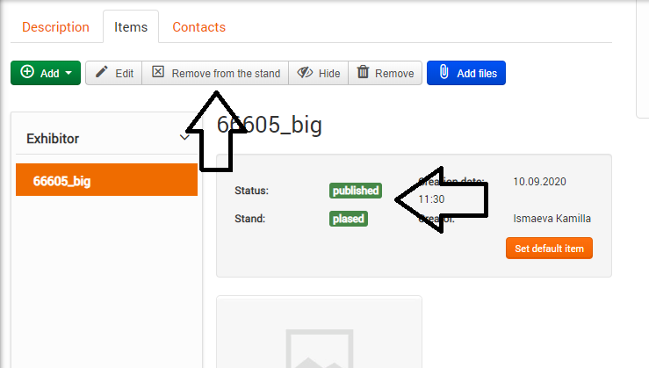
To better understand the purpose of the "Item" description fields, let's illustrate how the collected materials will be visible in the User's personal account. In the example below, there are 4 widgets with Exhibitor materials:
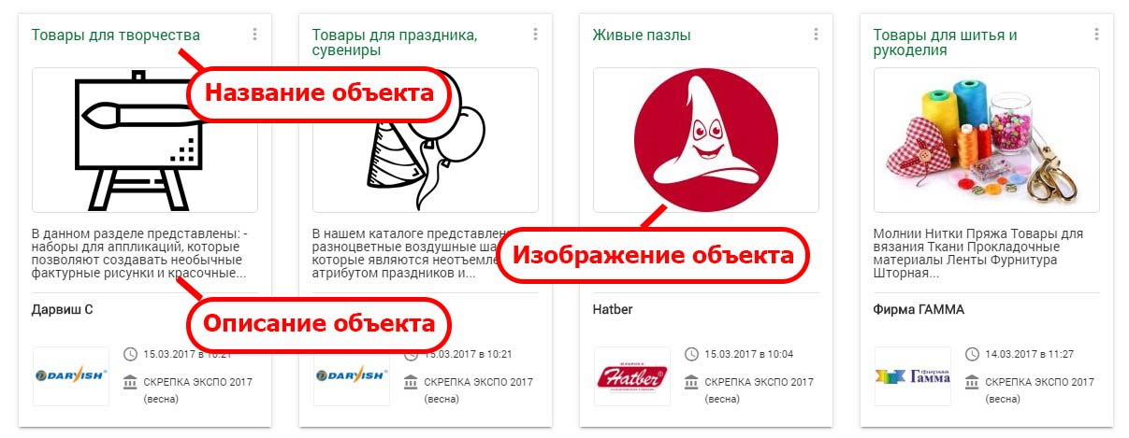

Using the object Category
A category is used to create a subset of objects. In this case, the category itself is placed on one of the zones of the terminal screen. Using a category allows you to go to a nested level and display the objects included in it.
Directory nesting is limited to only one level.
Adding a category
To add a category, do the same as when adding an object, just select the "Add category" command:
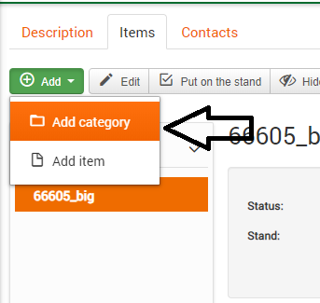
When creating subgroups of items, in the "Category" field, simply specify the category in which they should be placed.
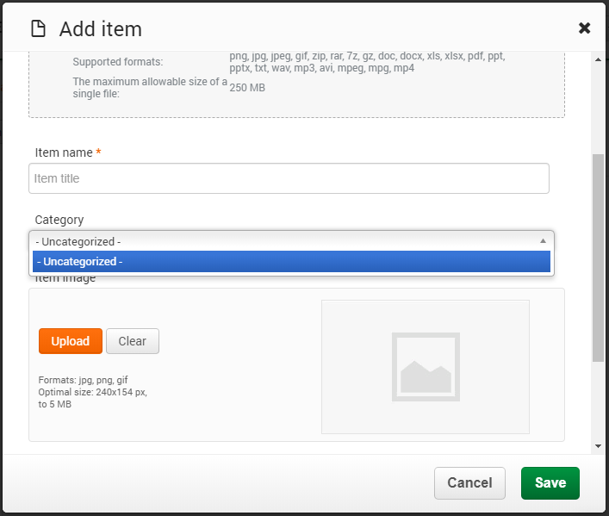

As a result, the main screen of the stand will contain items (not included in categories) and categories. When you click on an image of a category, you can "fall inside" and get access to its contents:
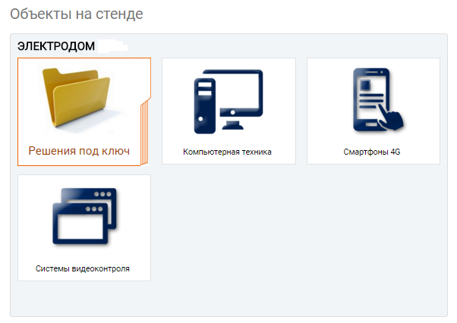

NOTE! Before you start adding a catalog, look at the site expodat.com as other Exhibitors did. Below are links to successful examples of the design of the object catalog:
http://expodat.com/companies/company/695-sandvik-coromant.html
http://expodat.com/companies/company/737-biofa.html
http://expodat.com/companies/company/735-remmers.html
http://expodat.com/companies/company/653-hatber.html

Additional information

When creating all descriptions, keep in mind that the exhibition visitor is offered a choice of interface language: national and international (English). If events are of a regional format, it is sufficient to fill in the information only in the national language. If the exhibition is of an international format, it is recommended to duplicate all the content with translations. To do this, use the "English info"tab in the object (or category) editing window.

How does the user receive information materials?

The information materials you add are placed in the service's cloud storage, which is open to all site visitors.
PAY ATTENTION:
Materials are transmitted not by sending them to the user's email address, but by adding objects to the User's Personal account.
By logging in to Personal account, the Visitor gets access to the materials and stands collected during the exhibition visit. All materials are presented in the form of widgets, provided with graphic images prepared by You and indicating the Exhibitor's data. When a User opens a marked position, he see the materials attached to it - attachment files that they can save to their computer.
Below is a screenshot of the User's personal account:
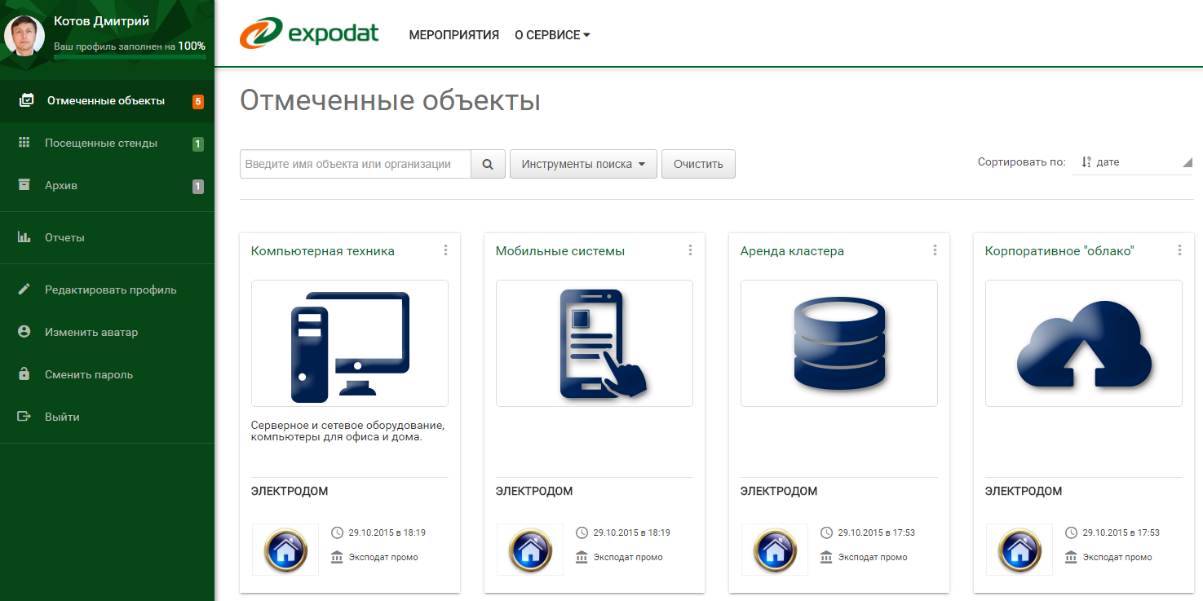

Viewing the results of using the service (reports)
The collected data is stored on the service's server in real time and is available as reports during the exhibition.
To view the received data, use your personal account and the "Reports" menu item:
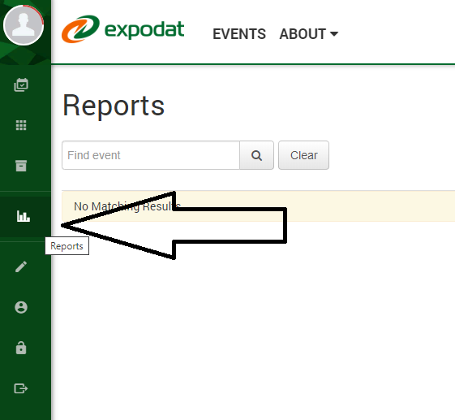
To view the collected database of visitors to the stand, create a " Catalog Report "(if you used the mode of transmitting information materials) or" Surveys Report " (if you used the questionnaire mode). To prepare a report, click on the corresponding widget and wait for the data to be presented.
The collected data is presented as a table, each record of which corresponds to the user's visit to your stand. For a compact view, the visible report line contains a minimum amount of information about the session.
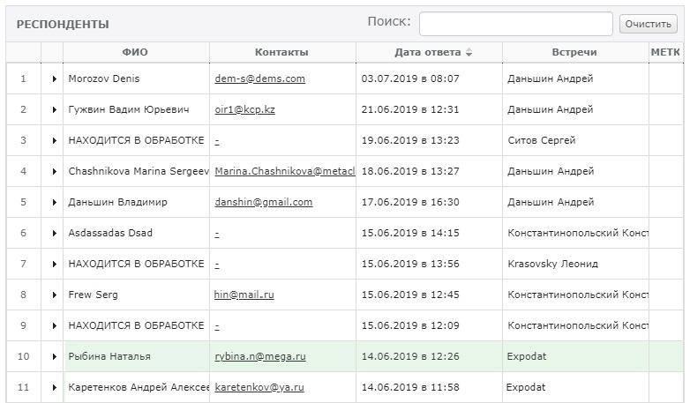
For more detailed information, click on the line – it will expand and be supplemented with new fields.
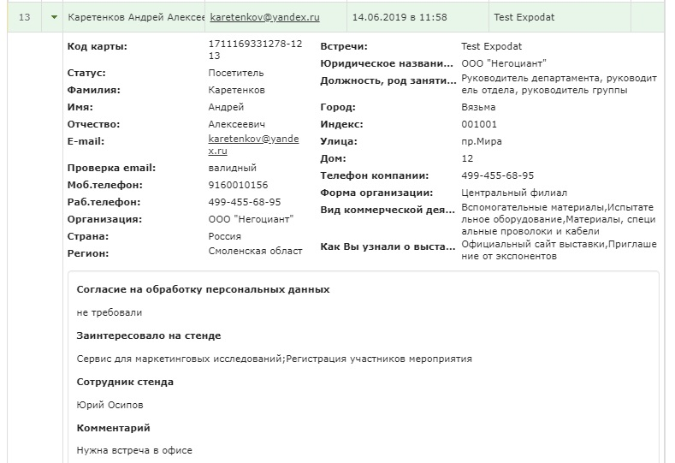
To get the most information collected, export the report to a spreadsheet file. To do this, click the "In Excel" button located near the report header.

Providing access to reports for other employees

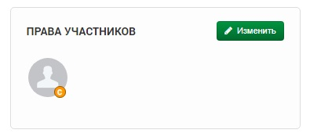
If you need to provide access to reports with the results of using the service to your colleagues, then you need them to register on the site expodat.com (you created personal accounts for yourself), and then you, as the administrator of your company's page, granted access to this page.
To grant access to colleagues, use the "Edit" button in the "Member Rights" window.
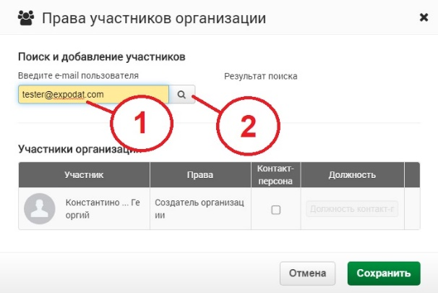
To add access to a colleague, enter their email address (which is also their username) in the search term and click the "Search" button.
The found user will be displayed in the search results. Click the "Add member" button to add the specified user to the list of allowed users to your company's reports. To complete the operation, click "Save".

